UNIVERSITY OF MELBOURNCE

COMP90019 RESEARCH PROJECT

25 CREDITS

The Feasibility of De-identification on Clinical Text

Based on External Dictionary

*Author: Supervisor:*

Ao Li Karin Verspoor

*A thesis submitted in fulfilment of the requirements*

*for the degree of Master of Information Technology*

Student ID: 798657

Department of Computing and Information System

May 30, 2018

**Abstract**

**Key words:** De-identification Tool; External Dictionary; Clinical Text; Pattern Match; Machine Learning

Declaration

I certify that

- this thesis does not incorporate without acknowledgement any material previously submitted for a degree or diploma in any university; and that to the best of my knowledge and belief it does not contain any material previously published or written by another person where due reference is not made in the text.

- where necessary I have received clearance for this research from the University’s Ethics Committee and have submitted all required data to the Department.

- the thesis is _____ words in length (excluding text in images, table, bibliographies and appendices).

Acknowledgements

Thanks to my kindly supervisor Professor Karin Verspoor for her professional assistance, insightful guidance and patient support through my project. She offers the great help to me when I meet some challenges.

Thanks to my dear parents for their fully understand which keeps me positive.

Thanks to my lovely friends for their encouragement which makes me strong.

Contents

List of Figures v

List of Tables vi

1 Introduction vii

2 Project Description viii

3 Performance Analysis ix

4 Conclusion x

# List of Figures

# List of Tables

# 1 Introduction

In this chapter, the background about the necessity and current exist problem with clinical narratives and de-identification approach will be illustrated in turn firstly. Then, the improvement direction of de-identification approach in this project will be briefly described.

1.1 Background

1.1.1 Necessity of Clinical Narrative

A clinical narrative, as its literal meaning, is a first person “story” written by a clinician that each of it can describe a specific clinical event or situation for a particular patient. Obviously, Clinical narrative plays an important role in clinical decision making [1]. The value of writing the narrative clinicians are that it allows clinicians to not only explain and shared them diagnose with their patients, but also current clinical practice with their professional colleagues. In addition, the narrative can encourage clinicians more deeply analyse and reflect on their clinical practice so that give them more insight for diagnosing [2].

1.1.2 Problem with Clinical Narratives

However, these clinical texts contain a large amount of patient privacy information, such as name, address, phone number etc., which let patients’ personal confidentiality on the line. Also, with the development of *Electronic Health Records* *(EHR)* system, a large number of patients’ data nowadays can be readily accessed and provided through clinical text for several various background people [3]. Furthermore, the *Health Insurance Portability and Accountability Act (HIPAA)* explains that people or authorities need to get patients’ consent and the approval of the Internal Review Broad *(IRB)* before making use of their clinical texts, but lacking controls of all aspects make these requirements implacably in practice.

1.1.3. Necessity of De-identification Approach

Thus, for the sake of solving the problem of leaking out patients’ confidential information from the clinical narratives, de-identification approaches appear. In general, de-identification approach is such a kind of method to identify and remove patients’ privacy data, called as *Protected Hospital Identifier (PHI)* defined by *HIPAA* [3]*,* from the clinical texts so as to protect their personal details. An example of de-identification effect on *MIST Scrubber Toolkit* is shown as *Figure.1*. [5].



original clinical text

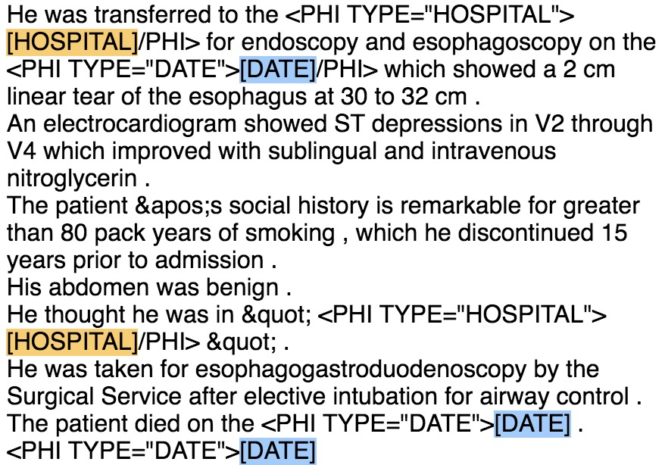

scrubbed clinical text

*Figure.1. Effect of De-identification*

1.1.4 Problem with De-identification Approach

From *Figure.1*., the effect of current existing de-identification process seems perfect, but there are still many problems with current exist de-identification tools. Three major de-identification problems are ‘under de-identification problem’, ‘wrong de-identification problem’ and ‘over de-identification problem’. Before introducing each of the problem in detail, the basic steps of the following examples to de-identify *PHI* tokens should be introduced firstly. The example tool below is firstly automatically divide the original text into different regions, shown as the grey frame in *Figure.2*. Then it will try to recognize and tag *PHI* tokens for different *PHI* categories in various colours. Finally, replace the recognized part with the specified replacer.

* ***Under de-identification problem*** means some of the *PHIs* are not recognized by the tool. For example, “Doctor Stable” cannot be recognized in *Figure.2. (i)*
* ***Wrong de-identification problem*** is that some of the *PHIs* can be recognized but in a wrong category. As shown in *Figure.2. (ii),* phone number is regarded as ID.
* ***Over de-identification problem*** is an opposite way comparing to the under de-identification problem*,* which recognize some plain clinical texts as target *PHI* tags but actually they are not. *Figure.2. (iii)* describes one of the situations that the plain text “CARCINOMA” is recognized and tagged as “DOCTOR”category.

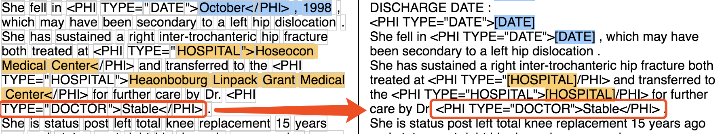

*(i) Under De-identification Example*

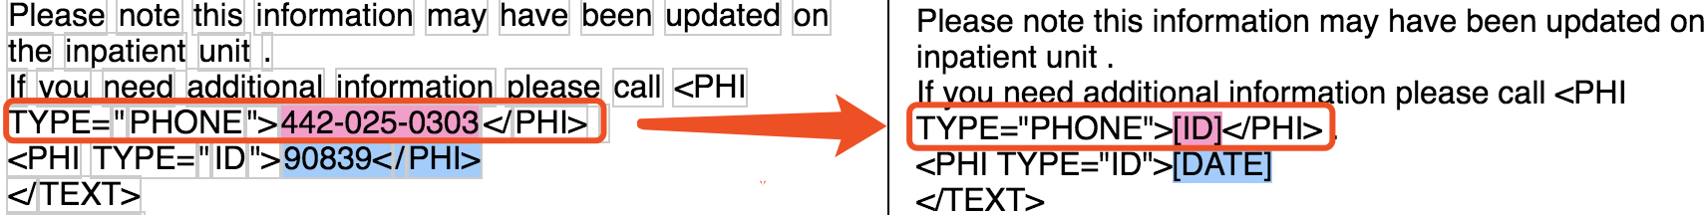

*(ii) Wrong De-identification Example*

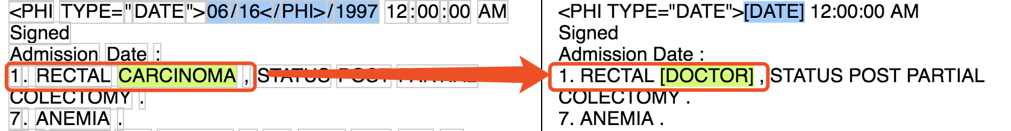

*(iii) Over De-identification Example*

*Figure.2. Some Problems with Current Scrubbed Tool*

1.2 Project Target

In this report, the main purpose of the project is to evaluate the performance of various exist de-identification tools.

The first part puts forward a suppose that whether to use an external dictionary that is trained from the training dataset can help the performance of the de-identification. The dataset the project used has multiple distinct *PHI* categories and some of them are not applicable in some de-identification tools, so the number and type of *PHI* categories used in this project are narrowed down. In addition, it will focus on analysing ‘*Location*’, *‘Hospital’*, *‘Doctor’* and ‘*Patient*’ four *PHI* categories and some parts will combine *‘LOCATION’ and ‘HOSPITAL’ as ‘Position’* category and *‘Doctor’ and ‘Patient’ as ‘People’* category. More specific explanation of these two methods will be depicted in Section 2.

In Section 2, an opposite approach, which is called ‘*Colander Approach’* in this project, will be also introduced as the second part. It is such a process that only keep the terms that are wanted in the clinical narratives, meaning that it considers all other terms as *PHIs* and then try to get rid of them. And the analyses are based on the same class of *PHI* categories as mention in the previous paragraph.

*Recall* and *Precision* will be considered as the measurements for the performance analysis in this project. The definition and illustration of both will be depicted in Section 2 in detail. And the results of the *Recall and Precision* on different de-identification tools will be shown in Section 3.

Conclusion and the direction of future development will be provided in Section 4, which will not only summarise the overall work in this project but also give an overview of a direction of future development based on the de-identification tools.

For the sake of giving more insight, all of the experiment data analysed in Section 3 will be attached on the APPENDIX.

# 2 Project Description

In this section, a comprehensive description of project environment settings and two types of de-identification approach will be introduced. Besides, four scrubber tools used in this project for de-identification will also be detailed illustrated.

2.1 Project Environment Settings

2.1.1 Data Corpora

Various *EHR* systems have provided distinct framework of clinical narrative and they are generally unstructured [2], so it is crucial to select one specific data corpora for the experiment. In this project, dataset from the *Informatics Biology and the Bedside (i2b2)* organization will be used. The reasons for choosing i2b2 data are that:

1. It is such a popular dataset in biomedical computing and has an increasing used for gaining insights to improve healthcare [6].
2. I2b2 dataset has provided sets of clinical notes from the *Research Patient Data Repository* at *Partners HealthCare* [7]. *PHI* terms have already tagged on those notes.
3. Multiple medical de-identification tools are supported to process on it. For example, some de-identification tools used in this project have particular commands for processing i2b2 data rather than the other datasets [5].

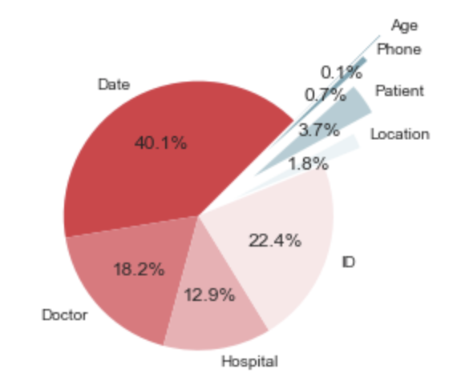

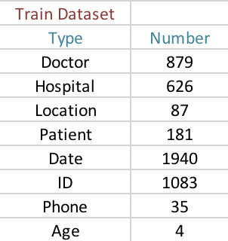

*Figure.3. Original Training Dataset*

More verbose, i2b2 annotated data corpora used in this project contains 201 clinical records, which consists 4835 *PHI* instances from 8 *PHI* categories as shown in *Figure.3.* There are 8 classes of PHI, but only ‘Doctor’, ‘Hospital’, ‘Location’ and ‘Patient’ categories are used in this project. Because there are adequate number of *PHIs* for those categories and they are much more meaningful than others on analysis.

However, because of small size and uneven distribution of the dataset, some parts of the analysis will combine ‘*Doctor’* and ‘*Patient’* categoriestogether *as* an integrated category, called*‘People’ category.* Similarly, *‘Location’ and ‘Hospital’ will be considered as* a *‘Position’ category.*

2.1.2 Evaluation Methodology

For the sake of analysing the performance of distinct de-identification toolkits, *Precision* and *Recall* are considered as the evaluation methodology and both of them are desirable to be high in the experiment. However, High *Recall* is much more preferred than high *Precision* in this project. Because the purpose of the project is to remove privacy information, it tends to remove as many potential PHI terms as possible and not quite matter if that is really a real *PHI* tokens. Therefore, *Precision* would be taken as the second priority in the project.

Importantly, as mentioned above, not all of the *PHI* terms are used in this project, so not all *PHI* terms in using dataset are grouped together but rather by their type when calculating *Recall and Precision*. For instance, all of the *‘Doctor’, ‘Patient’, ‘Hospital’ and ‘Location’* *PHI* terms should be grouped together in Section 3.1, because a holistic de-identification analysis based on these four categories will be illustrated in this section. However, it will only need to be integrated *‘Doctor’* and *‘Patient’* terms together or *‘Hospital’ and ‘Location’* terms together, as a ‘*People’ and a ‘Position’* analysis respectively instead in Section 3.2. Thus, the definition of *Precision and Recall* in this project are as following subsection.

2.1.2.1 Precision

The generally definition of *Precision* is the fraction of relevant instances among all of the retrieved instance. Namely, the precision for a category is the number of true positives over the total number of terms labelled as belonging to the positive class. As for this project, the definition of general *Precision* is the number of correct scrubbed terms on all *PHI* category divided by all scrubbed terms on all *PHI* category (as shown in *Figure.4. (i)*), meaning the proportion of correct de-identification terms within all of the scrubbed terms. Additionally, there are three variations of Precision’s definition in this paper, which is introduced separately as *Figure.4. (ii), (iii) and (iv).* They are following the principle of the general definition, but obviously for different purposes.

$$Precision= \frac{\# Correct Scrubbed Terms on All PHI Category}{\# Scrubbed Terms on All PHI Category}$$

*(i) Definition of Precision in general analysis*

$$Precision= \frac{\# Correct Scrubbed Terms on 'D, P, L, H^{'} PHI Category}{\# Scrubbed Terms on 'D, P, L, H^{'} PHI Category}$$

*(ii) Definition of Precision in holistic analysis (Section 3.1)*

$$Precision= \frac{\# Correct Scrubbed Terms on 'D, P' PHI Category}{\# Scrubbed Terms on 'D, P' PHI Category}$$

*(iii) Definition of Precision in ‘People’ analysis (Section 3.2)*

$$Precision= \frac{\# Correct Scrubbed Terms on 'L, H' PHI Category}{\# Scrubbed Terms on 'L, H' PHI Category}$$

*(iv) Definition of Precision in ‘Position’ analysis (Section 3.2)*

*Figure.4. Different kind of definitions of Precision in this project*

*Note: ‘D’**– Doctor, ‘P’ – Patient, ‘L’ – Location, ‘H’ – Hospital*

2.1.2.2 Recall

Generally, the definition of *Recall* is the fraction of relevant instances that have been found over the total amount of relevant instances. In other words, it is the number of true positive over the total number of terms that actually belong to the positive class. Take the project experiment data into the definition of *Recall*, it becomes, the number of correct scrubbed terms on all *PHI* category divided by the total number of all tagged *PHI* terms in the original text, which means the proportion of correct de-identified *PHI* terms in all of the PHI terms. Thus, the definition of *Recall* in general analysis can be taken as *Figure.5*. *(i).* Similar to *Precision*, it has another three variations for distinct analysis purposes as shown in *Figure.5. (ii), (iii) and (iv) respectively.*

$$Recall= \frac{\# Correct Scrubbed Terms on All PHI Category}{\# Tagged Terms on All PHI Category}$$

*(i) Definition of Recall in general analysis*

$$Recall= \frac{\# Correct Scrubbed Terms on 'D, P, L, H^{'} PHI Category}{\# Tagged Terms on 'D, P, L, H^{'} PHI Category}$$

*(ii) Definition of Recall in holistic analysis (Section 3.1)*

$$Recall= \frac{\# Correct Scrubbed Terms on 'D, P' PHI Category}{\# Tagged Terms on 'D, P' PHI Category}$$

*(iii) Definition of Recall in ‘People’ analysis (Section 3.2)*

$$Recall= \frac{\# Correct Scrubbed Terms on 'L, H' PHI Category}{\# Tagged Terms on 'L, H' PHI Category}$$

*(iv) Definition of Recall in ‘Position’ analysis (Section 3.2)*

*Figure.5. Different kind of definitions of Recall in this project*

*Note: ‘D’ – Doctor, ‘P’ – Patient, ‘L’ – Location, ‘H’ – Hospital*

2.2 De-identification Approach Description

There are two main types of method implemented in this project. The first one is to modify the general de-identification approach by using external dictionaries that are trained from the project data corpora. Then, in the second part, called *Colander* approach, is an opposite way of de-identification that will only contains the terms that are needed. The following two sub-section will describe these means in detail.

2.2.1 Modified De-identification Approach

In this part, a concept of training dictionary will be introduced as a way to modify the general de-identification approach. The steps of the modified de-identification method are as below:

1. Split original dataset into training part and test part:

Randomly select 90%, 80%, 70%, 60% and 50% from the original dataset as the training set respectively (*Figure.6.)* and the rest of the original dataset will be taken as the test dataset.

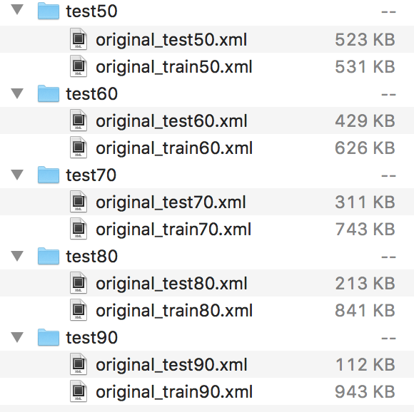

*Figure.6. Split original dataset*

1. Use the training part to train the external category dictionary:

Some of the scrubber tools do not differentiate ‘*Doctor’* and *‘Patient’* name or ‘*Location’* and *‘Hospital’* position, so combine *‘Doctor’* and *‘Patient’* category as *‘People’* and *‘Location’* and *‘Hospital’* category as ’*Position*’ in this project when training specified dictionary. It is such a simple way of training the dictionary, which just retrieves some tagged *PHI* terms for some particular category. Take *‘Position’* dictionary as an example, it is created by retrieving and collecting *‘Hospital’* and *‘Location’* *PHI* tags in training dataset. A simple collecting example in the training dictionary process is as *Figure.7.*

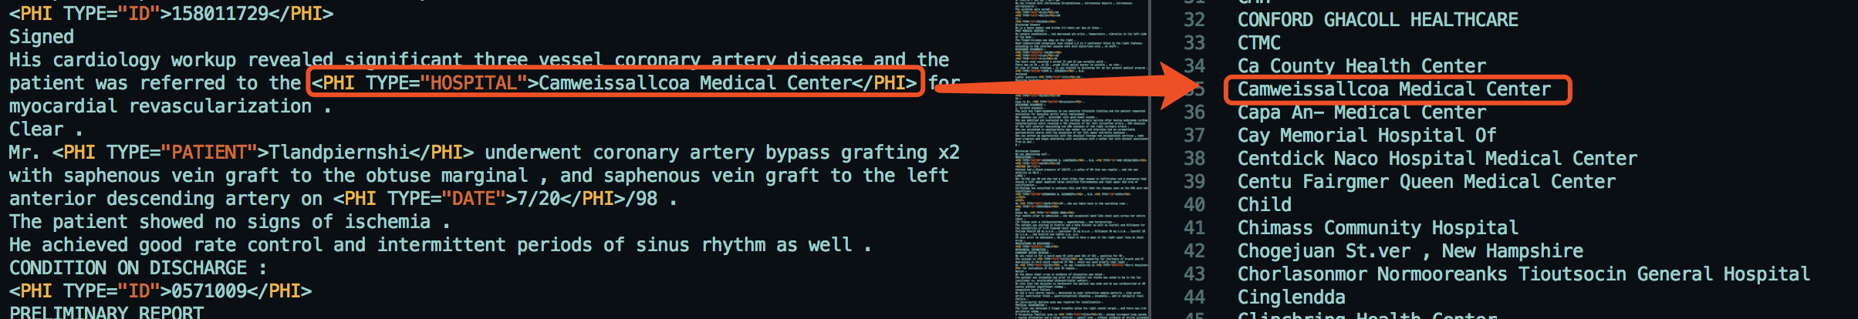

*Figure.7. Train the dictionary*

After collecting all of the *‘Hospital’ and ‘Location’ PHI* tokens, sort all of the stored *PHI* terms. The file after sorting will be regarded as a *‘Position’* external dictionary as *Figure.8*. So, the external dictionary is decided by the training dataset and there might me multiple various of *‘Position’* dictionary.

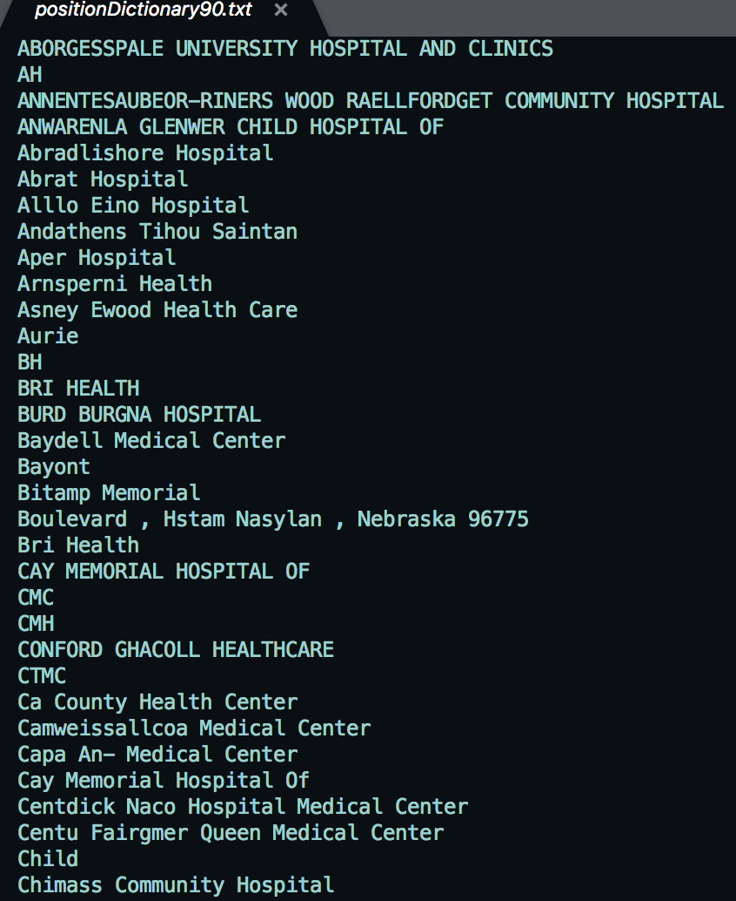

*Figure.8. An example of ‘Position’ dictionary*

1. Import the dictionary into the scrubber tools

All of the scrubber tools used in this project are based on two different principles for de-identification ---- ‘*Pattern Matching Based’* and ‘*Machine Learning Based’*, so there are two distinct way of using the external dictionary files.

First, to the pattern matching based scrubber tools, the dictionary file can be imported into and used directly as a matching file. What makes it work is basically because this kind of scrubbers are capable of comparing the stored *PHI* tokens from the dictionary files to all of the terms in the test dataset.

However, to the machine learning based scrubber tools, the dictionary file cannot be applied straightforward like pattern matching based scrubber tools, because this kind of tools would like to learn *PHI*s’ features itself by using machine learning algorithm. Thus, the original training dataset will be provided to the machine learning based tools instead of the learned external dictionary.

1. Test the performance on the test part of the dataset:

From now on, the scrubber tools can be used to de-identification on the test dataset. The specification about using each of the scrubber tools used in this project will be introduced in Section 2.3. Moreover, in Section 3, the scrubber personal performance and the comparison of de-identification effect among them will be shown.

2.2.2 Colander Approach

2.3 De-Identification Tools Description

In this part, four various scrubber tools that are used in this project for scrubbing the clinical narratives will be introduced in detail. They are the *HMS Scrubber, De-ID Scrubber, PHI-Reducer and MITRE Scrubber Toolkit (MIST).* As mentioned before, there are two kinds of principle for scrubbing.The first three of them are based on pattern matching principle and the last one is on the strength of machine learning based method. The purpose for choosing these tools are that, 1) All of them are supported to process on i2b2 data format. And 2) They are free, open source and easy to modify and improve. More detailed description of these tools is as below.

2.3.1 HMS Scrubber

*HMS Scrubber* is an *HIPAA* compliant and de-identification tool tailored for pathology reports [3]. In order to remove tagged *PHIs, HMS Scrubber* has three steps to do the de-identification [8], which are basically as following:

1. Pre-process and convert the clinical text into a specific XML format, which includes a header and a body portion of the clinical report. An example of the header section of the XML format is shown in *Figure.9*.

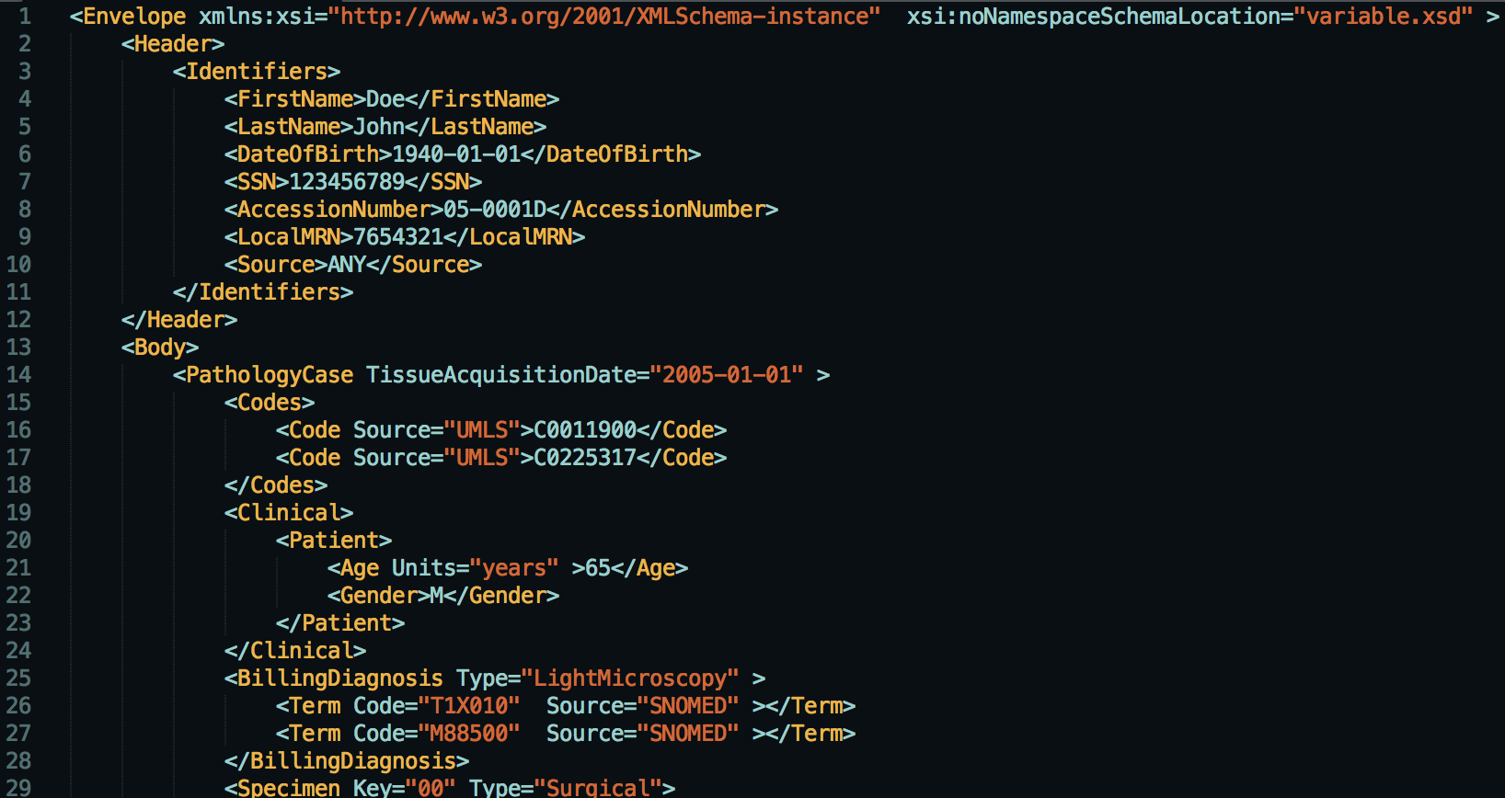

*Figure.9. The header of XML format in HMS Scrubber*

1. Use regular expressions (*RegExp*) and libraries for identificating potential *PHI* terms. There are about 50 *RegExp*s in the scrubber library. Additionally, popular suffixes and prefixes that are likely to stand for names (e.g. Dr., Mr. … etc.) are applied in this step for detecting. Take *‘Doctor’ PHI* category as an example, *HMS Scrubber* has a very detailed *RegExp* description for detecting potential doctor’s name pattern, like *Figure.10.*

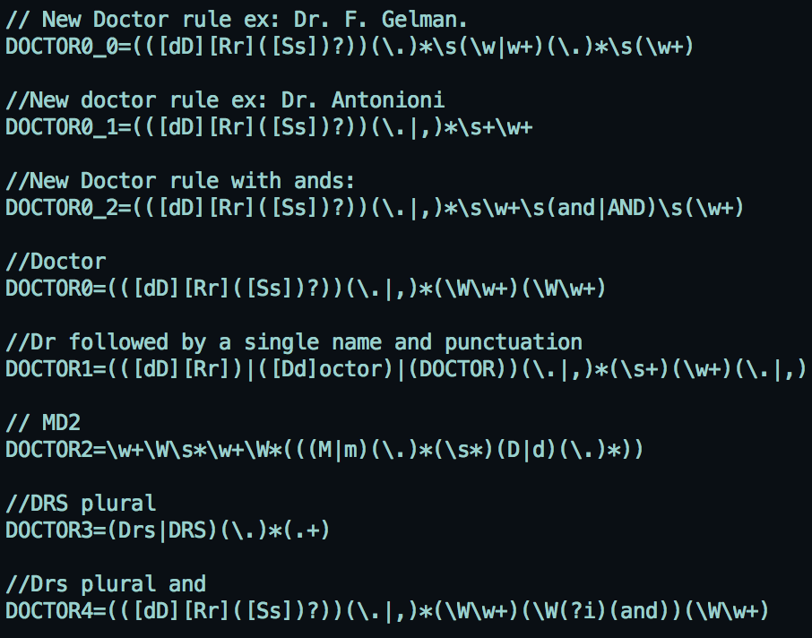

*Figure.10. RegExp for detecting Doctor*

Besides, there are two sorts of name library in this method that are respectively about Person and Hospital. Because these libraries are allowed to be augmented, the external dictionary generated from this project can be imported into library in this step. Part of exist name libraries in *HMS* *Scrubber* are depicted in *Figure.11.*

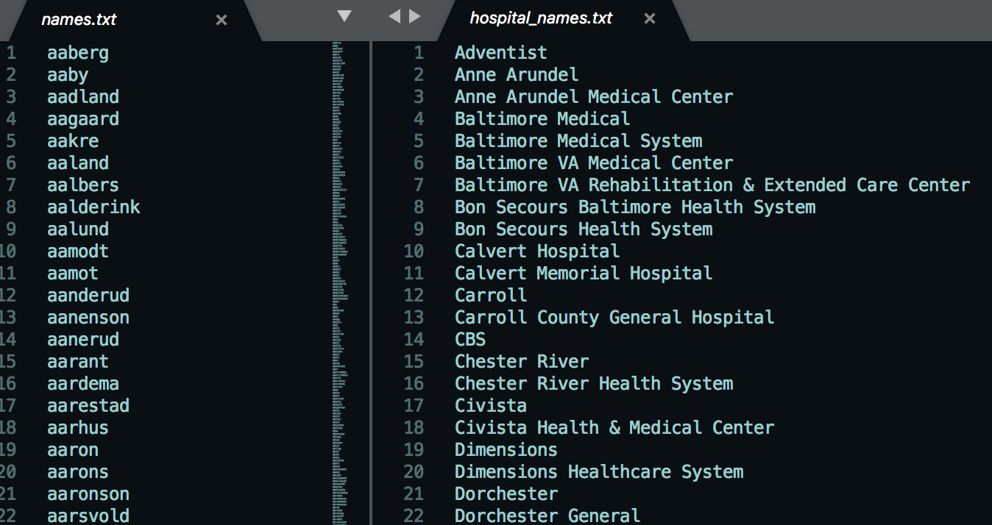

*Figure.11. Library for people and hospital names*

1. Replace all of the recognized words with a series of category tags.

The comparison of the original text and the scrubbed text output by *HMS Scrubber* is as *Figure.12.*



*Figure.12. The de-identification effect of HMS Scrubber*

2.3.2 De-ID Scrubber

*De-ID Scrubber* is a commercial tool created and developed at the *University of Pittsburgh* [9]. It also uses pattern matching algorithms with the help of dictionaries to recognize *PHI* terms. The de-identification steps in *De-ID Scrubber* is very similar to *HMS Scrubber*. However, the major distinction between *HMS Scrubber* and *De-ID Scrubber* is the number and the size of the dictionaries --- *De-ID Scrubber* has a more comprehensive dictionary library rather than *HMS Scrubber*. The basic process of *De-ID Scrubber* method is as following:

1. Pre-process and reformat original clinical narratives into a fixed structure (*Figure.13*.). Obviously from the diagram, texts imported into *De-ID Scrubber* need having a start, a body and an end section for each clinical record, so the original i2b2 format are required to be transformed into this fixed structure firstly.

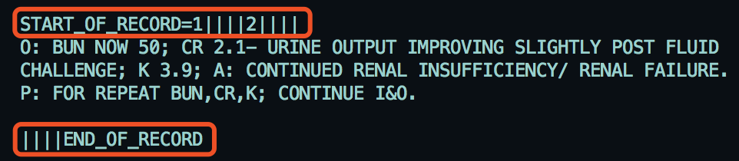

*Figure.13. The fixed structure in De-ID Scrubber*

1. Use *RegExp* and dictionaries to detect *PHI* terms. As mentioned above, the number of the original dictionaries in *De-ID Scrubber* libraries are much more complete than *HMS Scrubber*. For instance, there are many classifications of dictionaries about person and location names and parts of the dictionary are shown in *Figure.14. (i).* Besides, it adopts the *UMLS Metathesaurus* to help in identifying medical words that should be kept with the text that are described in *Figure.14. (ii).* Obviously, the training dictionaries that are generated from the project training can import into the scrubber in this step.

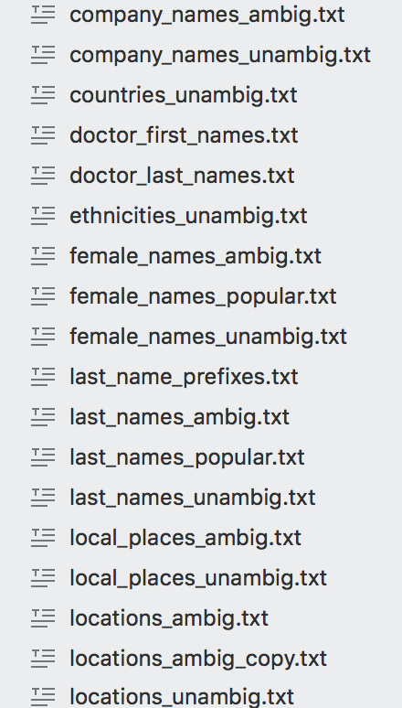 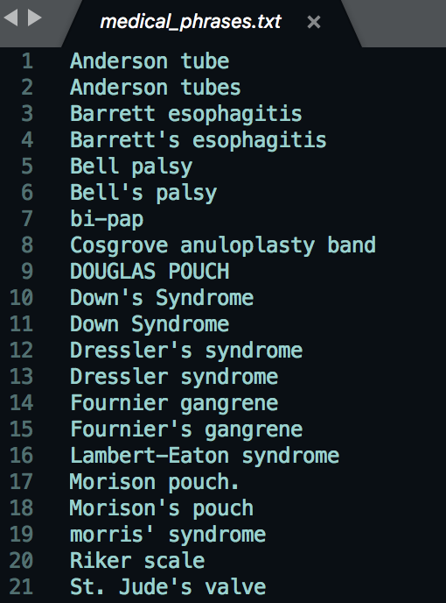

*(i) Comprehensive dictionary category (ii) Example of Metathesaurus*

*Figure.14. Example of dictionary in De-ID*

1. Replace all of the recognized words with a series of category tags.

The comparison of the original text and the scrubbed text output by *De-ID Scrubber* is as *Figure.15.*

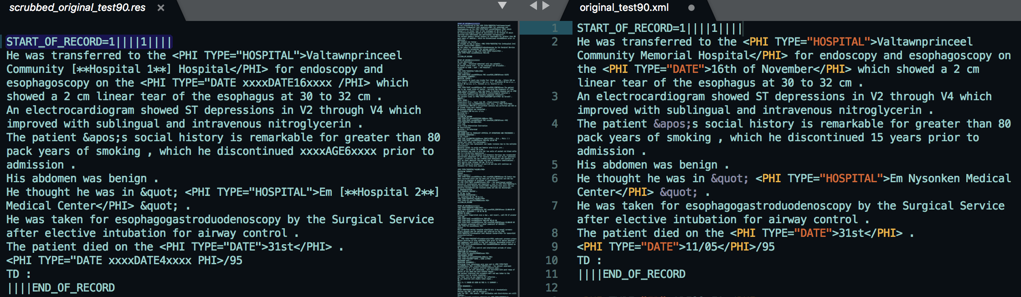

*Figure.15. The de-identification effect of De-ID Scrubber*

2.3.3 PHI-Reducer

*PHI-Reducer* is also a pattern matching based de-identification tools. Compare it to the above two scrubbers, the detection processes in *PHI-Reducer* are in multiple levels --- document level, sentence level and word level, which are more likely to identify the potential *PHI* terms to some extent. Moreover, *PHI-Reducer* is an application that makes use of the *Natural Language Toolkit (NLTK)* and the *SpaCy Packages*, so it covers two ways for identifying names by usingthese two packages separately. Also, what should be highlight is that *PHI Reducer* is such a toolkit that supports multi-processing, meaning that the de-identification processes can be run in parallel on multiple computers. On account of this advantage, it is likely to be more efficient than other scrubbers when the size of the processing dataset is large. However, there are not visible dictionary libraries used in this tool and it apples a large amount of *RegExp* and inline package libraries for identifying the potential *PHI* terms instead. The basic scrubbing procedures are as below:

1. Use *RegExp* to search for salutations. Most of the salutations are represented by a ‘.’ symbol, so this process must be done before the document is separated into sentences, meaning that it is in a document level. An example of the RegExp for checking salutations is depicted in *Figure.16*.

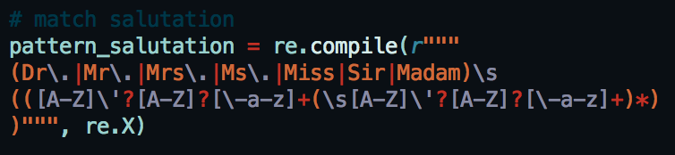

*Figure.16. An example of RegExp for salutations*

1. Split documents into sentences and use *RegExp* to identify PHI terms. In this level of *RegExp*, the pattern will consider only one word at a time. For example, it will identify the word ‘email’, ‘DOB’, ‘Postcode’ or any other word containing 5 or more digits. The external dictionary can be imported into scrubber in this step. *Figure.17.* gives an example of the ‘*Date’ RegExp* used in *PHI-Reducer*.

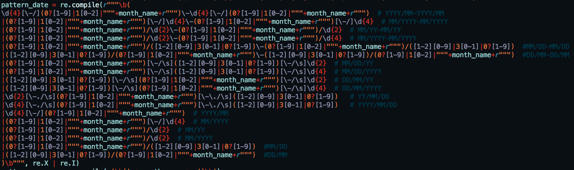

*Figure.17. Date RegExp in PHI-Reducer*

1. Split sentences into words and use *RegExp* to identify the context of *PHI* terms. For instance, checks the preceding words ‘age’ or ‘years’ for ‘DOB’. Another example is about the address, *PHI Reducer* regards an address is supposed to contain the following possible indicators in *Figure.18.,* so it is likely toidentify address by identify these key words.

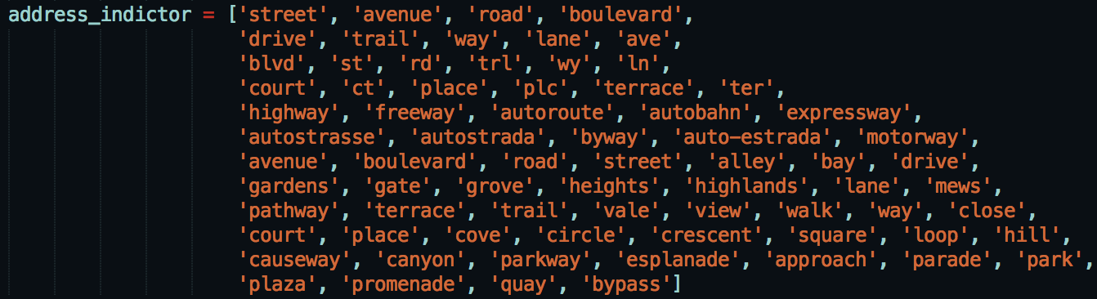

*Figure.18. Address indicator for PHI Reducer*

1. Use both *NLTK* and SpaCy toolkits to label a term and see whether they get the same label. If so, identify the word as a *PHI* terms. If not, add this term into a whitelist as a protected word.
2. Scrub all of the word that are recognized as a *PHI* words.

2.3.4 MITRE Identification Scrubber Toolkit (MIST)

*MIST* is the only machine learning based scrubber used in this project, which makes use of the *Conditional Random Fields (CRF)* classifier for automatically learning *PHI*s’ features on the training clinical records so as to de-identify and protect patients’ sensitive information [10].

There are two different de-identification tasks inside the *MIST* application that they are the *AMIA* task and the *HIPAA* task. In this project, only *AMIA* task is used in the experiment. The main reason of ignoring *HIPAA* task is that there is not much difference between these two tasks. Fundamentally, the distinction between these two methods is that *AMIA* task contains eight annotation classes, but *HIPAA* consists 18 categories, whose annotations are more detailed than *AMIA* task. However, i2b2 data is used as dataset in this project and the categories of i2b2 dataset is the same as in the *AMIA* task, so the level of category in *AMIA* task is completely enough for i2b2 data.

The general scrubbing process for *MIST* is as below:

1. Pre-process and reformat the training dataset. The original i2b2 data are not under appropriate format for *AMIA* task and there are two main reasons for that
2. The original i2b2 file is too large, but *MIST* can only process on small size of file. So, it is necessary to separate the original big file into various small portions and each portion becomes a new small file. Additionally, *MIST* separates large file by identifying the i2b2 record IDin the context and split the file by it*,* so then each of the small file will be an independent clinical record. For instance, 640.xml, 641.xml …. etc. in *Figure.19.* means the clinical record 640, record 641 … in original i2b2 training dataset respectively.

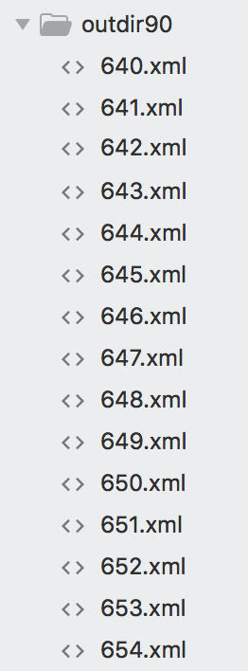

*Figure.19. An example of splitting the file*

1. The annotation style of i2b2 is *ENAMEX-style*, however, *AMIA* task need to run on *PII-style*. Therefore, need to reformat the annotations. The comparison between the original i2b2 data and data after reformatting is shown in *Figure.20*.

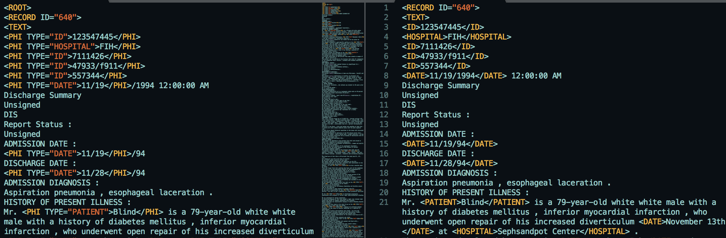

*Figure.20 The effect of the reformatting in MIST*

1. Use the reformatted files to train and build a model for de-identification. Because *MIST* is based on machine learning algorithms, implying that the external dictionaries cannot be imported into and used in *MIST* directly, reformatting raw files are needed to train the model straightforward instead of using the external dictionaries off the shelf.
2. Scrub the *PHI* terms by using the trained model. The key steps for processing de-identification are “zone, tag, nomination and transform”, which basically divide the original text into some small tokens, then tag each token and replace the *PHI* words with the specified replacer. A series of diagrams briefly shows the scrubbing process in *Figure.21*. Obviously, *MIST* firstly divides the original text into multiple small zones. Then try to analyse if *PHI* tokens exist in each of the small zones. And replace the recognised *PHIs* with the predefined replacer finally.

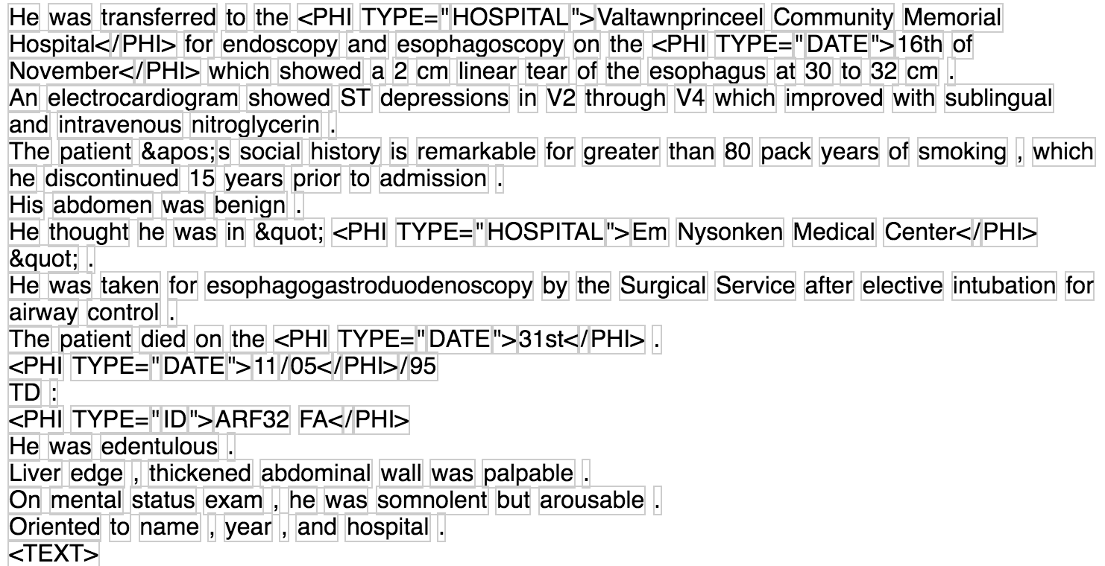 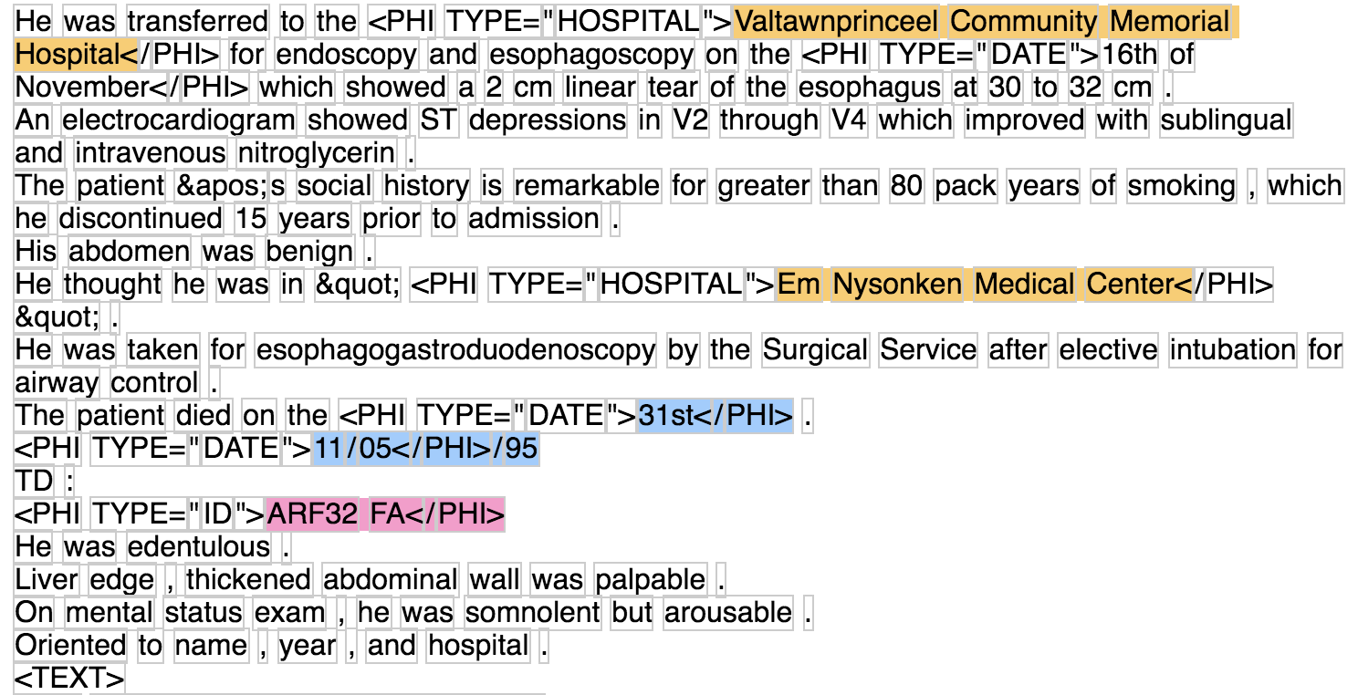

*(i) zone (ii) tag*

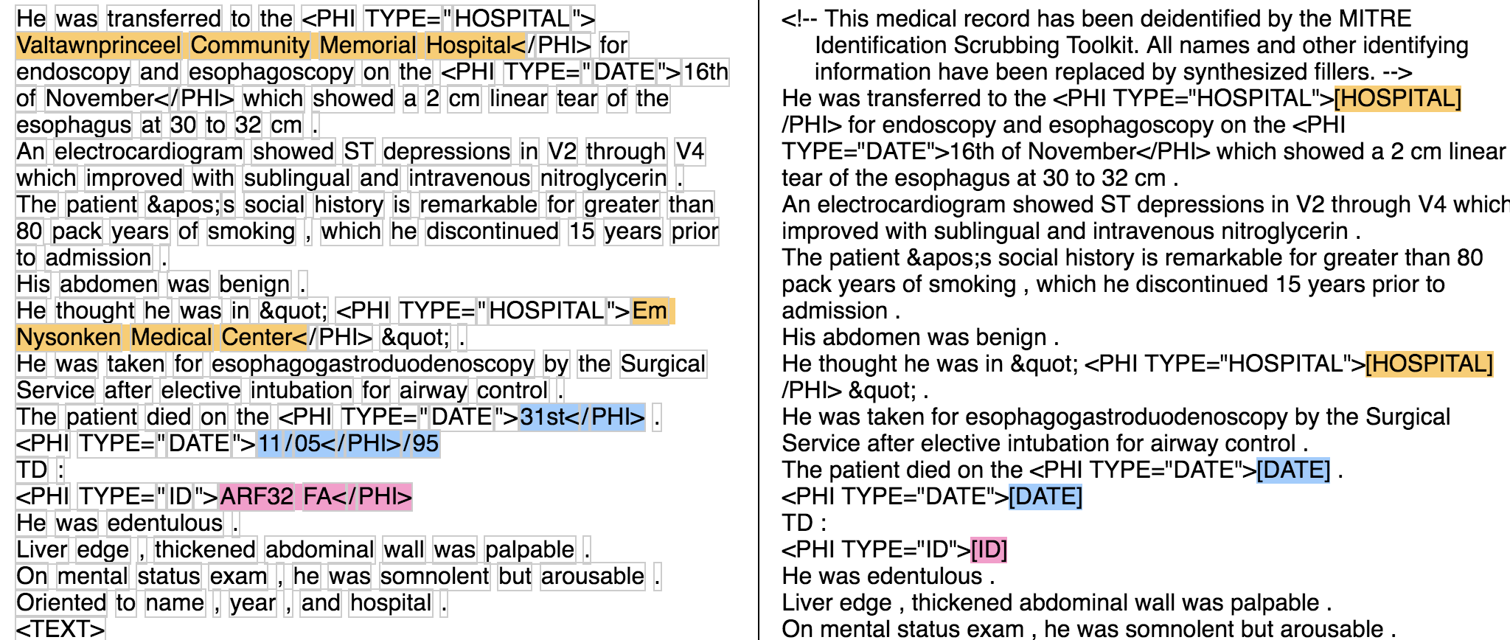

*(iii) nominate and transform*

*Figure.21. Basic steps for de-identification in MIST*

*Note:* ***zone:*** *find appropriate regions’ boundaries of the document to process.* ***tag:*** *add PII annotations.* ***nominate****: create replacement phrases for the regions of text tagged with PII annotation.* ***transform****: replace PII annotation with the replacer.*

# 3 Performance Analysis

In this section, some doubts and insights will be gained from observing the value of *Recall* and *Precision* in every experiment. Thus, a detailed performance analysis for the modified de-identification approach and colander approach will be presented.

3.1 Modified De-identification Approach Analysis

In order to assess the efficiency of the external dictionary, there are a series of analyses on various aspects that will be described as below:

* Firstly, the assessment will be generated from the comparison of performance on whether to import an external dictionary into the scrubbers or not among four various de-identification tools.
* Then, it will contrast different category dictionaries’ behaviours on various de-identification tools.
* Finally, a hold-out experiment and a ten-fold cross validation evaluation will be processed on the best performance scrubber that is analysed from the previous two steps to evaluate its stability.

3.1.1 External Dictionary Performance Analysis

An analysis of the performance of external dictionary is presented in this part. The external dictionary used in this section is such a hybrid dictionary, which contains *‘Doctor’* name, *‘Patient’* name, *‘Hospital’* position and patients’ *‘Location’* together. Because different scrubber has distinct de-identification ability on various *PHI* categories, the purpose of using this hybrid dictionary is to see the general de-identification performance on every de-identification tools. It is worth to noting that the original i2b2 dataset has already separated into five types, whose training dataset’s size are 90%, 80%, 70%, 60% and 50% of the original dataset. In this way, the number of the clinical records are needed for training can be inferred from the de-identification performance.

Moreover, as mentioned above, there are two kinds of scrubber ---- pattern matching based and machine learning based. And the external dictionary cannot be directly imported into the machine learning based scrubber. Thus, this report will analysis pattern matching based tools and machine learning based tools in a different way.

3.1.1.1 Pattern Matching Based Scrubber Analysis

Since *HMS Scrubber, De-ID Scrubber and PHI Reducer* are all pattern matching based toolkits, they can be compared with each other. As shown in *Figure.22*., the first and second row describe the comparison of *Precision and Recall* respectively among different tools with various sizes of the training dataset, the left two diagrams means the *Precision and Recall* on the original scrubbers and the right two charts represents the performance on scrubbers after importing external dictionary.

Obviously, to the original scrubber, *HMS Scrubber* gets the highest *Precision*, which is about 90%, but with the lowest *Recall* which is approximately 5.29%. *PHI-Reducer* behaves in an opposite way that the lowest *Precision* is 12.93% and the highest *Recall* is 53.49%. And, both of the Precision and Recall in *De-ID Scrubber* performs at a middle level. 　More concrete data are attached on the *Appendix.1*.

Then, after importing the hybrid external dictionary, the *Precision* in both *HMS and De-ID Scrubber* has a dramatically decrease. However, both of their *Recalls* are grown vigorously at this stage that *HMS Scrubber* has five-fold increase and *De-ID Scrubber* has increased by 3 times. In addition, there is only a slight fluctuation for *PHI-Reducer* and it is always in an intermediate level among three scrubbers*.*

Additionally, there are 5 different hybrid external dictionaries generated from 5 different training datasets, which is depicted in various colour in *Figure.22*. There is not much distinction among them from the diagrams to a particular original de-identification tool, but to the improved scrubbers, larger training size could get a relative higher *Recalls*. Actually, it achieves the desired results. The reason why it looks like that is because the training datasets are just for training the dictionary and have done nothing with the original scrubbers, it will only have an impact on the improved scrubbers and the larger training dataset for establishing the dictionary, the potential *PHI* tokens are more likely to be recognized and then the higher *Recalls* will get. But there are still some other objective reasons would also have an effect on this result. Such as, the error of the random sampling, the diversity of the using dataset … etc. But no matter what, the charts still show the tendency that the three improved scrubbers get a relative low *Precisions* after modification, but relative high *Recalls* and it turns higher with larger training dataset.

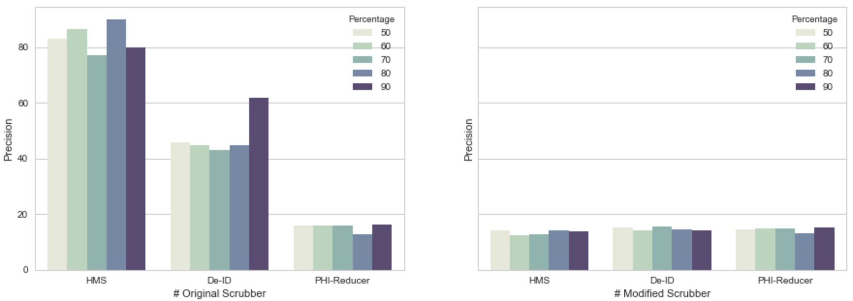

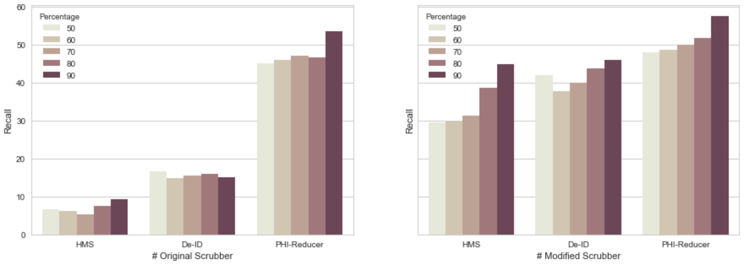

*Figure.22. The Comparison of Precision and Recall*

*on Pattern Matching Based Tools*

3.1.1.2 Machine Learning Based Scrubber Analysis

To the machine learning based scrubber, the analysis is in a different way. Because *MIST* is the only machine learning based tools used in this project, the performance analysis on *Precision and Recall* will be achieved by comparing the results with its different number of training iteration. It is well-known that the number of training iteration plays an important role in machine learning algorithm, which can sensitively control the training model so that avoids the model becomes underfitting or overfitting. *Figure.23* is a curve graph which describes the tendency of the *Precision and Recall* in different limitation of iteration based on *MIST*.

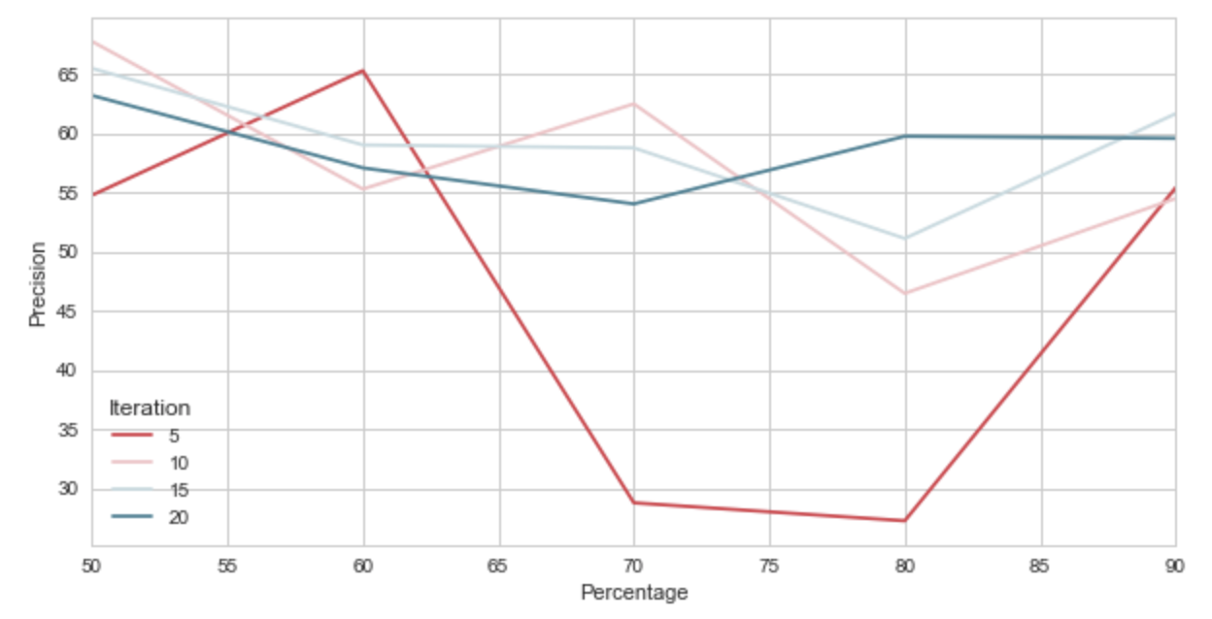

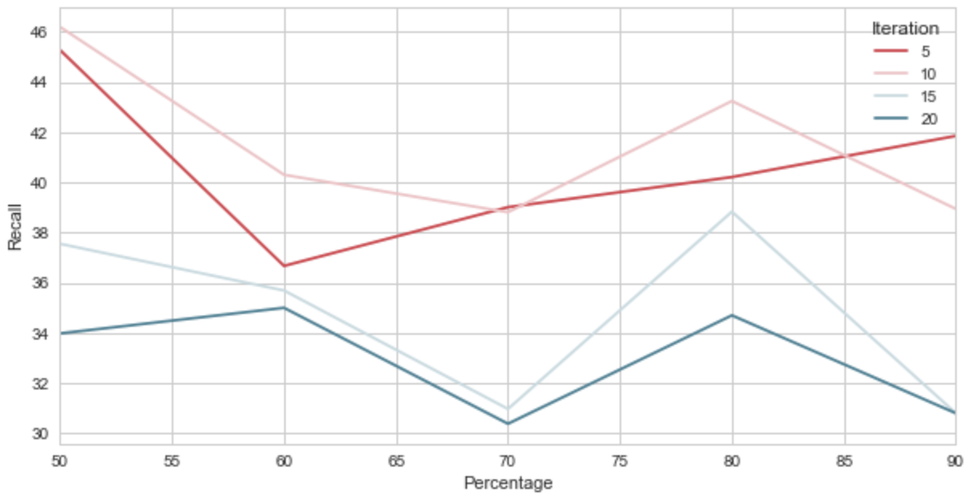

*Figure.23. The Comparison of Precision and Recall*

*on MIST with different setting*

Firstly, as can be seen from the graph, the upper chart represents the fluctuation of the *Precision and* the under stands for the *Recall*. And four different colour curves mean four numbers of iterations, which are 5, 10, 15 and 20 times. The highest *Precision* in *MIST* is67.74%, which is nearly 20% less than the best performance pattern matching based tool. And the highest *Recall* is approximately 46.20%, which is slightly lower than 53.49% in pattern matching based method. However, the highest *Precision and Recall* in *MIST* are both from the same iteration. This means that when the number of iteration is 10, *MIST* will give a relative high *Precision and Recall*, which seems more stable than pattern matching based tools that there is a large difference between the *Precision and Recall* and the highest *Precision and* *Recall* are from different de-identification tools.

Also, from the diagrams, it is clearly that when the number of iteration is 15 and 20, both of them achieve a relative high *Precision* but comparative low *Recall*. In this situation, the training model for de-identification can be regarded as becoming overfitting. In contrast, it is apparent from the charts that when the number of iteration is 5, training model is considered as underfitting. Because the fluctuation of the red curves is much more dramatically than the other three curves and the *Precision* is lower than the *Recall* in a large range of percentage.

In addition, as is demonstrated in the graphs, *Precision and Recall* are high enough when the training data is about 50%. It reveals one advantage of the machine learning based algorithm that PHI terms’ features can be well-learned only on a relatively small training dataset, though the dataset need to be tagged and this should be done manually to a great extent.

3.1.2 Different Dictionary Performance Comparison

In this part, a *‘Position’* and a *‘People’* external dictionary will be introduced respectively in turn in the following sub-sections. It is worth to noting that there is not distinction with people’s name and locations’ name in *PHI-Reducer* after scrubbing and machine learning based toolkit cannot directly use the imported external dictionary, so the analysis in this part is only based on *HMS Scrubber and De-ID Scrubber*. In addition, as mentioned above, *‘Location’* and *‘Hospital’* categories are combined as *‘Position’* category and *‘Doctor’* and *‘Patient’* *PHI* categories are combined together as ‘*People’* category.

3.1.2.1 Only Import ‘Position’ Dictionary

According to *Figure.24*., the bar graphs show the *Precision and Recall* on the original *HMS Scrubber* and *De-ID Scrubber* and these scrubbers after importing the *‘Position’* dictionary. More specifically, the first row of charts represents the change of the *Precision* and the second row of charts stands for the *Recall*.

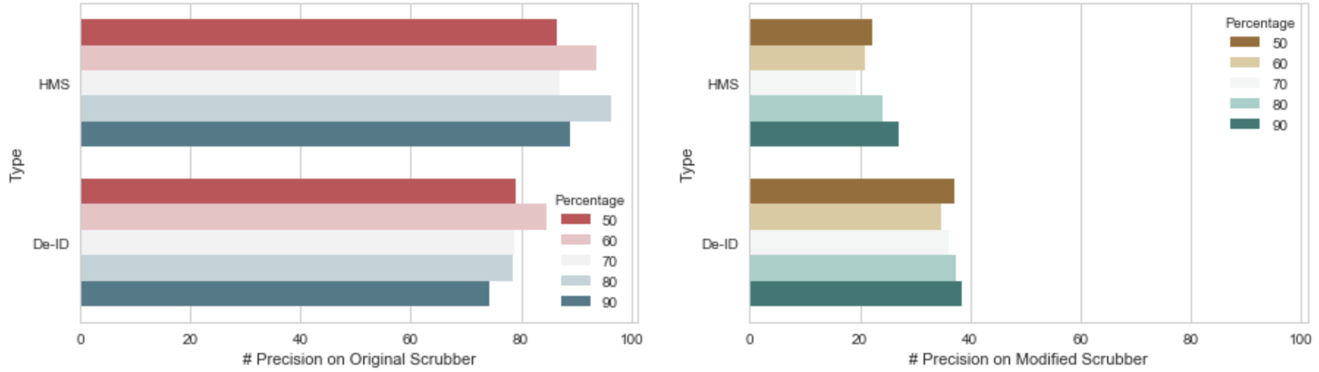

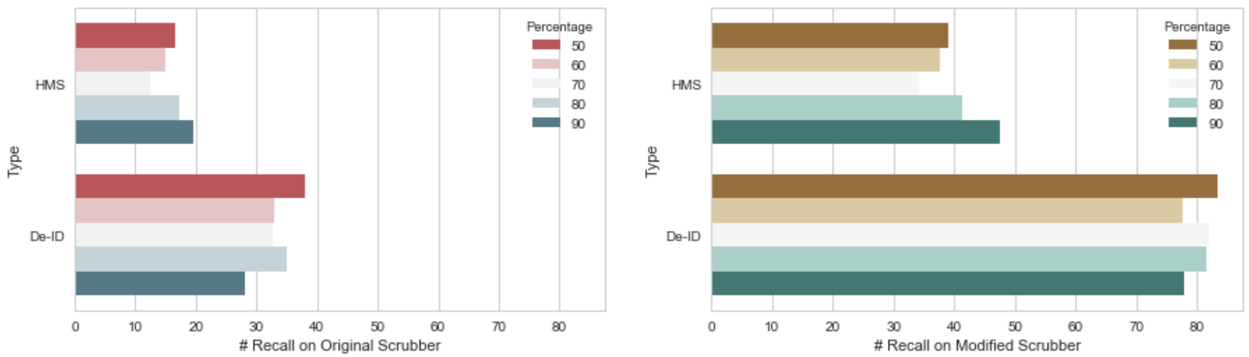

*Figure.24. The comparison of Precision and Recall on*

*original HMS and De-ID Scrubber with the scrubbers*

*after importing the ‘Position’ Dictionary*

As can be seen from the graphs, before importing the ‘*Position’* dictionary, *HMS Scrubber* gets a relative higher *Precision* but a lower *Recall.* However, after importing the dictionary, *De-ID Scrubber* performs better not only on the Precision side but on the Recall side. Moreover, although the *Precision* on *De-ID Scrubber* has decreased double, but the *Recall* has grown about three times, which is very desirable and achieves about 83.43% when the training dataset is only 50% of the original. It represents that only small size of the training data can train a good enough *‘Position’* dictionary based on i2b2 dataset.

Additionally, to both two scrubbers, there is a considerable increase occurs on *Recall*, but an opposite tendency on *Precision*, which means that the external dictionary can really help the de-identification tools to find the *PHI* terms. Although at the cost of some extent of *Precision,* the improved Recall can highly protect more patients’ privacy information. In other words, the external dictionary can improve scrubbers to retrieve more *PHI* terms in the clinical narratives so as to tag and de-identify them.

3.1.2.2 Only Import ‘People’ Dictionary

Although the way for using the training ‘*People’* external dictionary and the procedures processing on de-identification is similar to ‘*Position’* dictionary, the performance of ‘*People’* dictionary is shown in a completely different way as depicted in *Figure.25*.

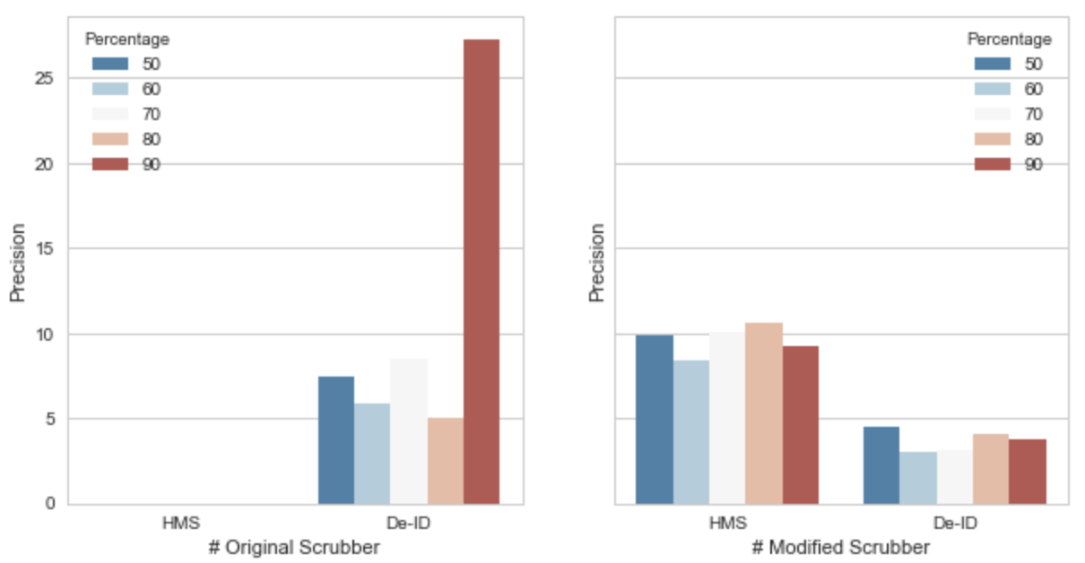

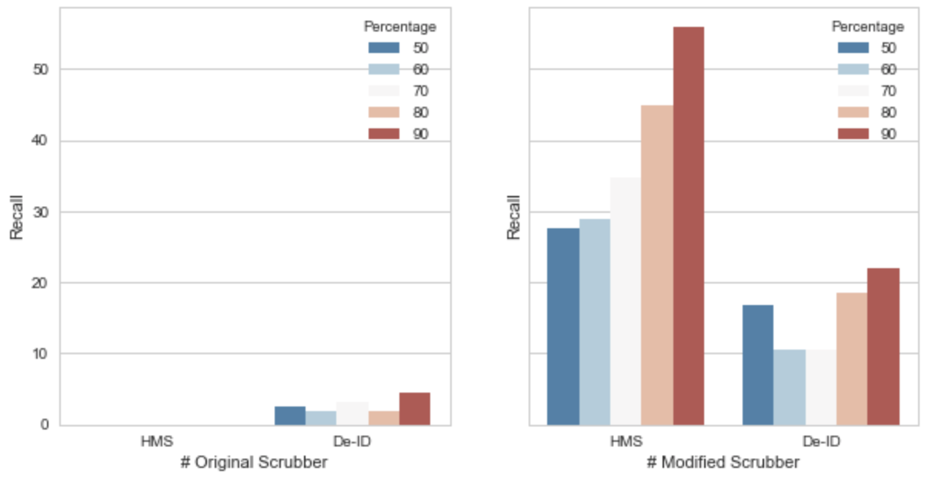

*Figure.25. The comparison of Precision and Recall on*

*original HMS and De-ID Scrubber with the scrubbers*

*after importing the ‘People’ Dictionary*

Surprisingly, both *HMS Scrubber* and *De-ID Scrubber* do badly in scrubbing people’s name. As is shown in the diagrams, the original *HMS Scrubber* can hardly de-identify a name in the test dataset, which makes both of the *Precision and Recall* become 0. And although the original *De-ID Scrubber* performs a little bit better than *HMS Scrubber,* the average of *Precision* is still only about 6% except for the highest value in *Precision* and the situation is pretty similar in *Recall* as well as the average of Recall is approximately 3%.

The good news is that after modified the scrubbers, the value of *Precision and Recall* are both effectively increased. And the performance of *HMS Scrubber* is relatively satisfied than before, which receives about 56% and 11% for the highest *Recall and Precision*.

However, comparing to the *‘Position’* dictionary, *‘People’* dictionary still performs much worse. It must due to multiple reasons for poorly identifying people’s name, but one of the major reason could be the diversity of people’s name. For example, people’s names are different a lot in different regions and pattern matching based scrubbers always use regular expression for identifying name pattern. To be honest, it is very difficult to write a series of comprehensive regular expressions that can completely describe all kind of names. Thus,

3.1.3 Variation of De-identification Tool

In this part, there are two different analyses about the original *HMS Scrubber* and *DE-ID Scrubber*.

1. ***Analysis on “Best Scrubber”***: In this part, *HMS Scrubber* and *DE-ID Scrubber* will be combine together for achieve a better performance on scrubbing. Because from *Section 3.1.2*, *Recall* from *HMS Scrubber* achieves better on *‘People’* training dictionary than *De-ID Scrubber*, but the performances on ‘*Position’* are completely in an opposite way. In the following subsection, it will establish a new scrubber, which plan to use ‘*People’* part in *HMS Scrubber* and ‘*Position’* part in *DE-ID Scrubber* so that to see if a better de-identification scrubber can be produced.
2. ***Analysis on Only Importing Training Dictionary:*** Another analysis wants to show both of their performances by only using the training dictionaries. In other words, it will remove all of the default dictionaries and libraries in the tool itself so that to evaluate whether a training dictionary is enough for de-identification on a scrubber or not.

3.1.3.1 Mixed De-identification Tool

3.1.3.2 Only Use Training Dictionary

3.2 Colander Approach Analysis

# 4 Conclusion

# Reference

[1] Murphy, J.W., Choi, J.M., & Cadeiras, M. (2016). The Role of Clinical Records in Narrative Medicine: A Discourse of Message. *The Permanente Journal,* 20(2), 103-108. doi:10.7812/TPP15-101.

[2] Ferrández, O., South, B., Shen, S., Friedlin, F., Samore, M., & Meystre, S. (2013). BoB, a best-of-breed automated text de-identification system for VHA clinical documents. *Journal Of The American Medical Informatics Association*, *20*(1), 77-83. doi:10.1136/amiajnl-2012-001020.

[3] Meystre, S. M., Friedlin, F. J., South, B. R., Shen, S., & Samore, M. H. (2010). Automatic de-identification of textual documents in the electronic health record: a review of recent research. *BMC Medical Research Methodology*, *10*70. doi:10.1186/1471-2288-10-70.

[4] Ferrandez, O., South, B. R., Shen, S., Samore, M. H., Meystre, S. M., & Friedlin, F. J. (n.d). Evaluating current automatic de-identification methods with Veteran's health administration clinical documents. *Bmc Medical Research Methodology*, *12.*

[5] Mist-deid.sourceforge.net (n.d.). MIST: The MITRE Identification Scrubber Toolkit. AMIA TASK [online] Available at: <http://mist-deid.sourceforge.net/current_docs/html/index.html> [Accessed 30 Mar, 2018]

[6] i2b2: The Intergrating Biology and the Bedside organization. (2005). [online] Available at: <https://www.i2b2.org/NLP/DataSets/Main.php> [Accessed 31 Mar,2018]

[7] Stubbs, A., & Uzuner, O. (2015). Annoatating longitudinal clnical narratives for de-identification: The 2014 i2b2/UTHealth corpus. *Journal Of Biomedical Informatics*, S20-S29. Doi:10.1016/j.jbi.2015.07.020.

[8] Beckwith, B.A., Mahaadevan, R. Bails, U.J., & Kuo, F. (2006). Development and evaluation of an open source software tool for deidentification of pathology reports, *BMC Medical Informatics & Decision Making*, 6(1), 12-10. Doi:10.1186/1472-6947-6-12.

[9] Gupta, D., Saul, M., & Gilbertson, J. (2004). Evaluation of a Deidentification (De-Id) Software Engine to Share Pathology Reports and Clinical Documents for Research. *AMERICAN JOURNAL OF CLINICAL PATHOLOGY*, (2). 176.

[10] Aberdeen, J., Bayer, S., Yeniterzi, R., Wellner, B., Clark, C., Hanauer, D., & … Hirschman, L. (2010). The MITRE Identification Scrubber Toolkit: Design, training, and assessment. *International Journal Of Medical Informatics*, 79, 849-859. doi:10.1016/j.ijmedinf.2010.09.007.

Appendix

Experiment Analysis Data

1. Analysis Data for section 3.1.1.1:

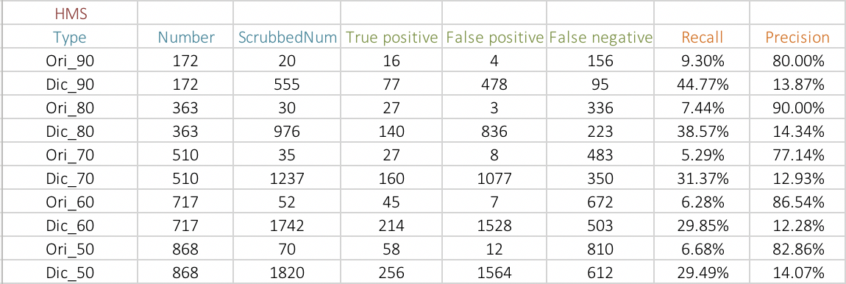

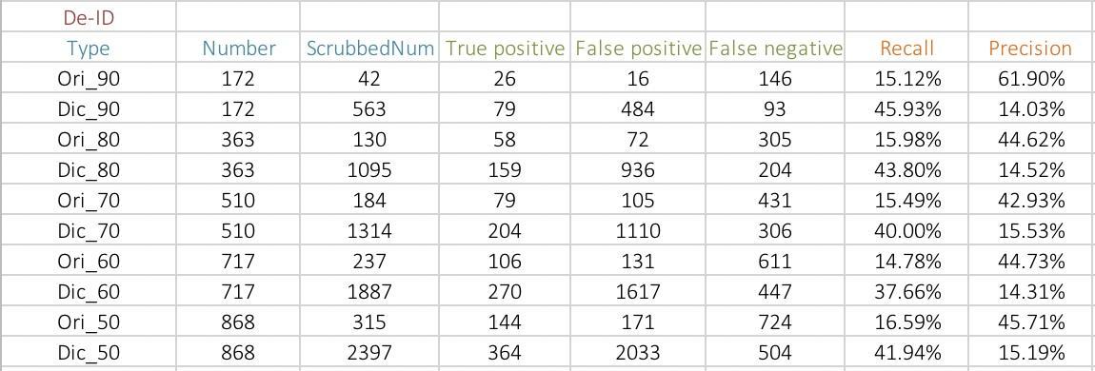

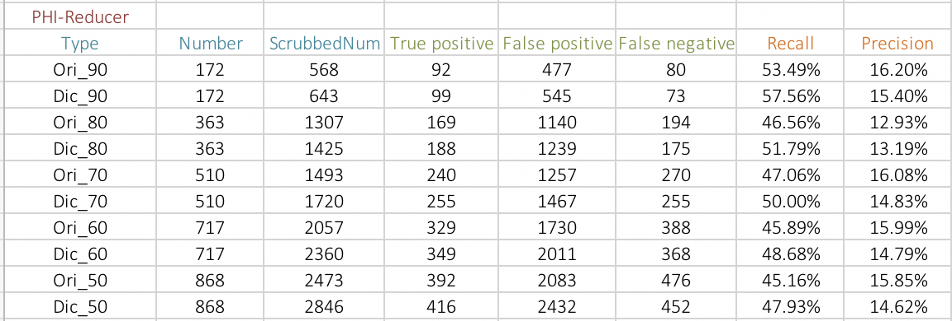

The Total Analysis among

The Pattern Matching Based Scrubber Tools

2. Analysis Data for section 3.1.1.2:

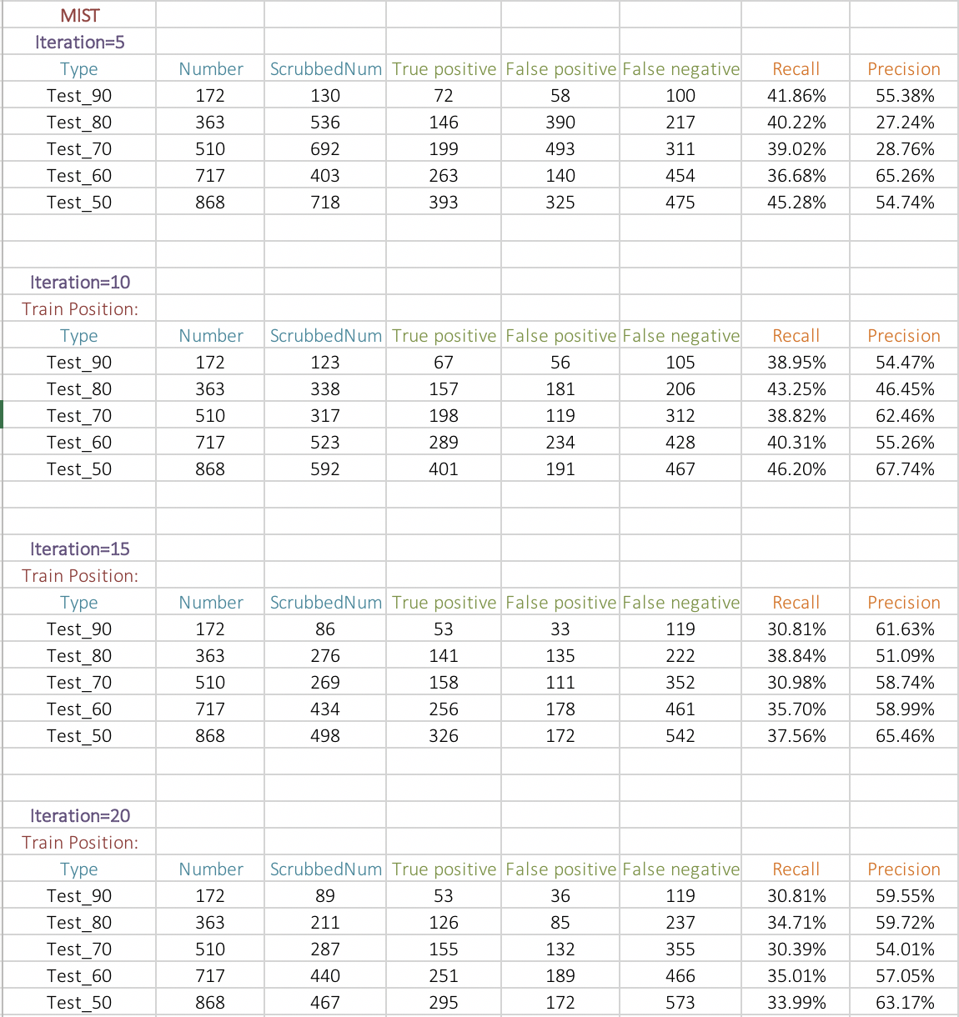

The Total Analysis among

The Machine Learning Based Scrubber Tools

3. Analysis Data for section 3.1.2.1:

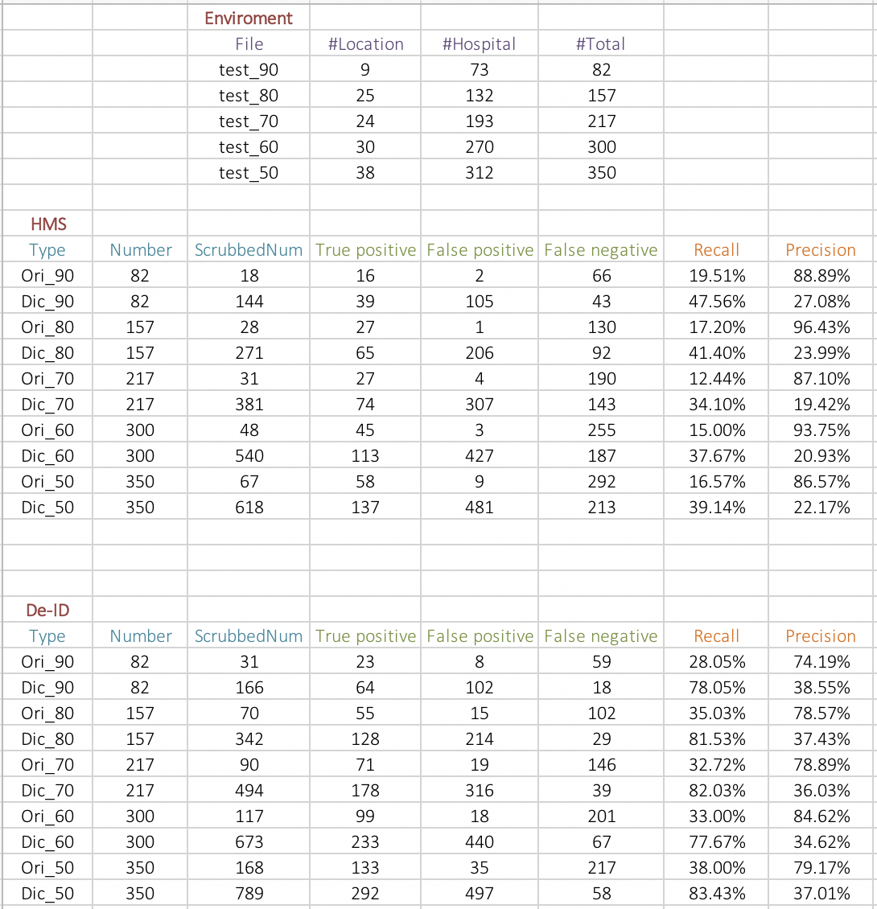

*Note: Position = Location + Hospital*

4. Analysis Data for section 3.1.2.2:

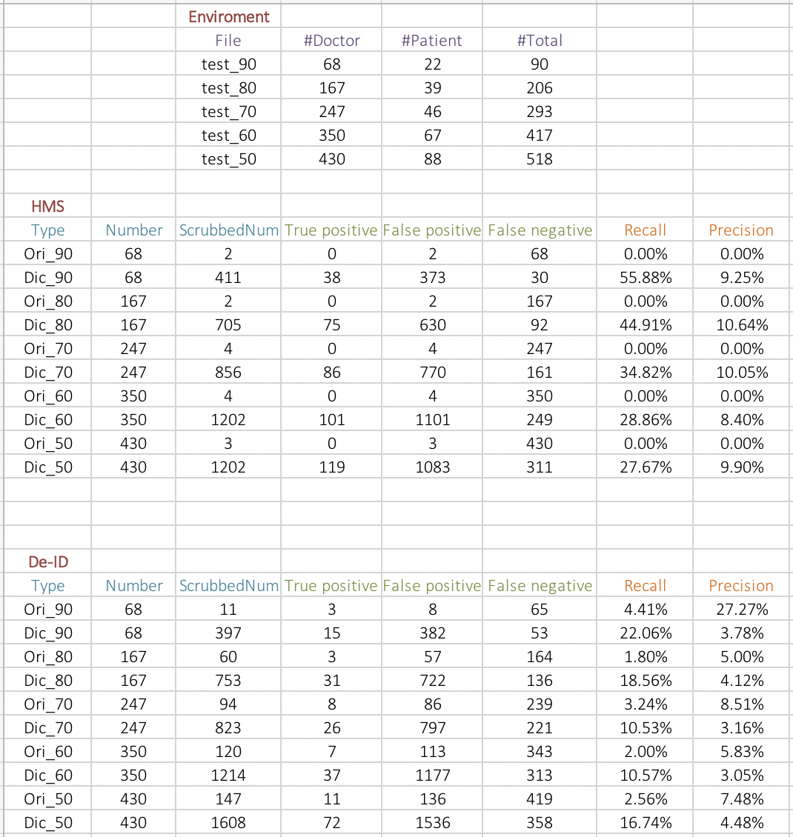

*Note: People = Doctor + Patient*